**What is Electrostatics.**

Electrostatics is a branch of physics that deals with the phenomena and properties of stationary or slow-moving electric charges. Electrostatic phenomena arise from the forces that electric charges exert on each other and are described by [Coulomb’s law](https://byjus.com/jee/coulombs-law/). Even though electrostatically induced forces seem to be relatively weak.

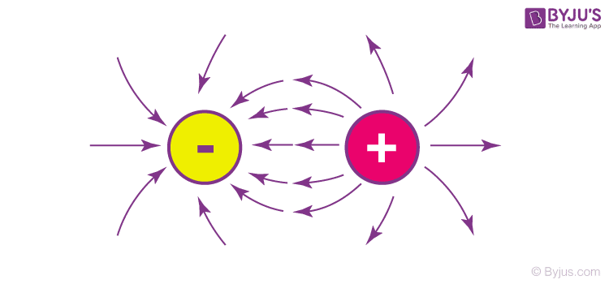

Coulomb’s Law of Electrostatics

**Coulomb’s Law**

Coulomb’s law defines the electrostatic forces in terms of repulsion and attraction. It is a kind of inverse square law, like the gravitational force. Coulomb’s law of electrostatics states that the magnitude at which electrostatic charges repel or attract is “directly proportionate” to the magnitude of charges when multiplied. It is also proportionally inverse to the square distance between the charges.

**What is An Electric Field?**

An electric field is defined as the region where the force is applied. Electric fields vary, spending on the area where the force has been applied last. Lines usually help us to visualize what exactly the electric field looks like. It moves from the positive to the negative point of charge. These lines are parallel to the electric field. The lines are the regions that surround the point-charged particles. If we view it from one point, from where the charge is flowing, the lines move radially outwards.

**Positively Charged Particles**

Here, the number of positively charged ions, i.e. protons, exceeds the number of negatively charged ions which are the electrons. Neutralization of this field occurs when the negative charge equals the positive charge in the field.

**Negatively Charged Particles**

In this case, negatively charged particles, i.e. electrons exceed the number of positively charged particles which are the protons. More electrons are needed and need to be equal in number to neutralize.

**Neutral Particles**

Neutral are those particles that do not have any charge. They are called neutrons. However, a neutral field will be formed not just by neutrons, but also by an equal number of electrons and protons.

**Example Showing Electrostatics Forces**

* Rubbing a rod against the cloth
* Nylon clothes can sometimes get attached to the skin due to extreme rubbing
* Photocopy
* Television screen after it is just turned off